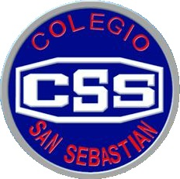
COLEGIO SAN SEBASTIAN
STO. DOMINGO 2078
STGO-CENTRO
Colegio San Sebastián
Santiago Centro
Departamento de Inglés
Profesor Luis Alvarado P.

EVALUACIÓN FORMATIVA PRIMERO MEDIO

- Completa tu nombre, sigue las instrucciones y responde cuidadosamente.
- Terminada la evaluación debes enviarla al siguiente correo: inglescss2020@gmail.com
- Buena suerte!

A Complete with the correct form of past perfect

1 I _______(be) in this place before
2 People______________(arrive) to this city many years ago
3 I_____________ (meet) many friends before I moved to other country
4 I_____ some hours during the morning (read)
5 She_____ me in the park (not/see)
6 I_____________ (work) in this factory before
7 By the time we arrived, the show____ (start)
8 The shop_______________ in yesterday (not/open)

C Complete with correct form, past simple or past perfect

1 By the time we_____________ (arrive) to school, the lessons had started
2 Manchester City_____________ (win) many matches, when the league finished
3 When she_________ (return) from Europe, she__________ (visited) many countries
4We _______ (go)) the supermarket before it____________ (close)
5 Cristobal Colón_____________ (discover) America when he___________ (return) to Spain
6 When she ______ (go) to the concert, she _____ (buy) the tickets .
7 I____________ (do) my homework when the teacher __________ (check) it.
8 I _______________ (clean) the house when my parents___________ (arrive)

