COLEGIO SAN SEBASTIAN
STO. DOMINGO 2078
STGO-CENTRO
Colegio San Sebastián
Santiago Centro
Departamento de Inglés
Profesor Luis Alvarado P.

EVALUACIÓN FORMATIVA CUARTO BASICO
MINIBEASTS

NAME______________________________________________ Pts 16/____

- Completa tu nombre, sigue las instrucciones y responde cuidadosamente.
- Terminada la evaluación debes enviarla al siguiente correo: inglescss2020@gmail.com

A Lee la descripción y escribe el nombre del insecto

Bee – snail – dragonfly – ant - grasshopper

1 It lives in a Shell. It is really slow ________________
2 It yellow and black. It can fly __________________
3 It can jump very high ____________________
4 It has a long body. It can fly ________________
5 It is black and small __________________

B Responde utilizando: yes, it has /no it hasn’t

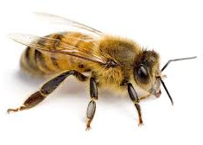1 Has it got eight legs? 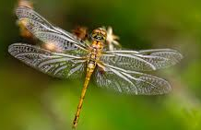 2 Has it got six wings?
_________________ __________________

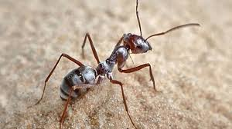 3 Has it got antennaes? 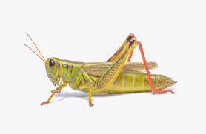 4 Has it got legs?
_________________ __________________

C Lee las oraciones y escribe la habilidad que cada insecto puede realizar

Fly – walk – jump – smell - see

1 A grasshopper can _______ very high
2 Bees has got two antennaes. They can_______ flowers
3The ladybird has got four wings. It can________ very fast
4 Ants has got six legs. They can _________ a lot!
5 Snails are very slow. They use their tentacles to______

