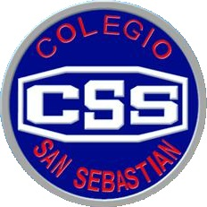
COLEGIO SAN SEBASTIAN
STO. DOMINGO 2078
STGO-CENTRO
Colegio San Sebastián
Santiago Centro
Departamento de Inglés
Profesor Luis Alvarado P.

EVALUACIÓN FORMATIVA TERCERO MEDIO

NAME______________________________________________ Pts 15/____

- Completa tu nombre, sigue las instrucciones y responde cuidadosamente.
- Enviar al siguiente correo: inglescss2020@gmail.com

A Choose the correct alternative

1 “Anna has returned” my Mum said
My Mum said that, Anna____
a had returned
b had returning
c returned

2 “I did the homerwok”, he said
He said that he___ the homework
a had done
b done
c had did

3 “He is going to school”, she said
She said that, he___ to school
a were going
b was going
c going

4 “He will read the book”, they said
They said that, she__ the book
a won’t read
b would read
c read

5 “He goes to work everyday”, she said
She said that, he___ to work everyday
a had gone
b went
c go

6 “Thet have repaired the car”, he said
He said that, they__ the car
a had repaired
b have repaired
c repaired

7 “I will study tomorrow”, he said
He said that, he___
a would study tomorrow
b will study tomorrow
d would study the next day

8 “He watched the movie last year”, he said
He said that, he___ the movie ___
a had watched
b had watched/the year before
c had watched/last year

B Write the correct form of reported speech

9 “I bought a new camera”, he said
He said that,_________________
10 “He will go to school”, she said
She said that,________________
11 “He has sent the e mail”, they said
They said that,_______________
12 “He is reading now”, she said
She said that,________________
13 “The movie has finished”, he said
He said that,____________________
14 “I visited Madrid last year”, she said
She said that, ____________________
15 “I will study at university next year”, he said
He said that,____________________

